1.Write a blog on difference between HTTP1.1 VS HTTP 2?

1.HTTP means hyper text transfer protocol.

2.HTTP is a protocol that exchanges information between a client computer and a server.

Client=> sends request to server vis get or post method

Server=> sends response like a html page to the client

3.**Flaws in http:**

HOL: HEAD OF LINE BLOCKING (nowadays we have 6 TCP connections for http1.1)

Repetition of header request

4. **Features of HTTP2.0:**

Page load speed increased through:

Compression of request header

*Binary protocol*=> in HTTP1.1 it is text protocol now it is changed to binary protocol.

Request multiplexing through one TCP connections

*HOL blocking (head of line)-* package blocking=> it uses the HPACK specification as a simple and secure approach to header compression. Both server and client maintain a list of headers used in the previous client server requests.

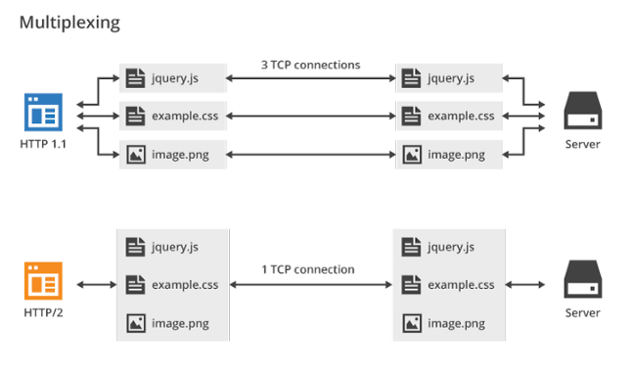

2. OBJECTS AND ITS INTERNAL REPRESENTATION:

Javascript object is a collection of named values having state and behaviour (properties and value)

Objects are variables.an objects may have different properties.

The objects are written as name and value pairs (name

and value ) separated by colon.

Syntax:

Object Name: property name

Example: myCar.year = 1969;

var myCar = new Object();  
myCar.make = 'Ford';  
myCar.model = 'Mustang';